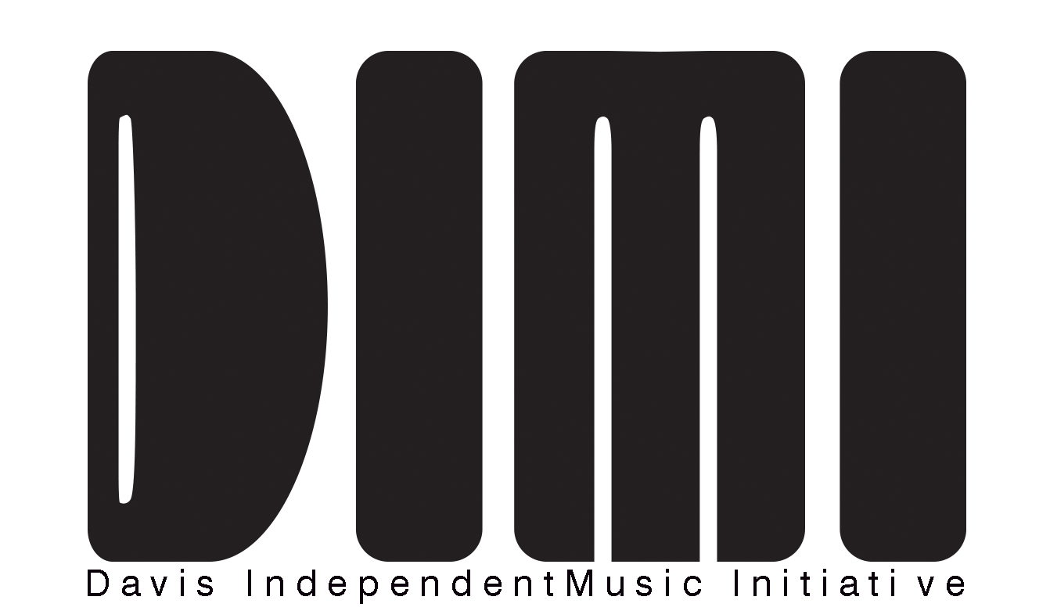
2022 Davis Independent Music Initiative Grant

The Davis Independent Music Initiative (“DIMI”) has been allocated grant funds from the Davis Arts & Cultural Affairs Fund. This money is designated to support a pilot annual program aimed at the creation of a new original musical album or work. The fund will support an artist or band residing in Davis who will write, record, and present this new original musical work for the community and world to appreciate. Up to $10,000 has been allocated to continue this program into 2022.

Projects that support the voices or individuals of Black, Indigenous People of Color (BIPOC), Black Lives Matter (BLM), and other initiatives that promote cultural and social equity are strongly encouraged to apply.

The successful Applicant/Grantee must do the following:

- Complete the recording of a new, unreleased, musical work within 24 months of April 1, 2022;
- Host the new musical work on a platform that the community can access for free (this does not preclude applicant from monetizing and otherwise using their work in any manner they deem appropriate; this is, in fact, encouraged by DIMI);
- Publicity related to the release of the new musical work must acknowledge support, sponsorship, or underwriting by the City of Davis Arts & Cultural Affairs and DIMI;
- Grantee must in good faith make efforts to work with DIMI to perform their work in the City of Davis upon completion, wherein members of the community are not charged to attend. Davis Live Music Collective (“DLMC”) has agreed to make itself available for production support of this event;
- Grantee must agree to attend two to three DIMI committee meetings after receipt of their grant to assist in the next year’s iteration of the award; and
- Grantee must provide up to an hour of advise to the following year(s) recipient(s) quarterly in support of that recipient(s)’ own award.

Selection Process

Funding will be allocated on a one time basis. The application deadline will be 5:00 PM April 1, 2022. A committee consisting of members of the Davis community including, musicians, music fans, and business owners/employees that benefit from a thriving local music scene will evaluate all applications according to the criteria identified in this application. The committee will complete its review and choose a grantee within 90 days of the application deadline. Applicants may be required to interview with a committee panel following application submission. Additionally, applicants may be required to provide references related to their ability to complete the project proposal.

Applicant Requirements

- The applicant must reside in Davis, CA, or have at least one band member residing in Davis, CA.
- Preference will be given to emerging bands/musicians, but those musicians must demonstrate an ability to complete the project and produce a work that would have an audience.
- Applicant must submit digital links to three examples of their original musical work (phone quality recordings are acceptable, videos are encouraged). Please no more than 15 minutes in length total.
- Applicant must attempt in good faith to create a proposed budget for their project so that DIMI has a sense of where the applicant believes they need the most financial assistance.
- Applications are due by 5:00 PM PST on April 1, 2022 to davisindependentmusic@gmail.com

Evaluation Criteria

Applications will be evaluated based on the following criteria:

- Artistic Merit
- Proposed Plan for Completion (including proposed budget)
- Release Plan and Strategy for Promotion
- Feasibility: the likelihood that applicant will be able to follow through with the proposed project
- Potential Audience
- Prior Accomplishments and previous work
- Personal or professional reference attesting to Applicant's ability to complete project

(continued on next page)
Proposal for DIMI Award
(Please fill this form in, in as much detail as possible)

General Information
Musician/Band Name________________________________________________________
Principal Contact Name/Title__________________________________________________
Contact Phone: Day__________________________ Evening________________________
Contact E-Mail ______________________________________________________________
Applicant’s Mailing Address ____________________________________________________

Applicant’s Website _________________________________________________________

Applicant’s Social Media Handles:

- Facebook:
- Instagram:
- Twitter:
- Bandcamp:
- Other:

Amount requested: _______ (up to $10,000.00)
Certification
By signing, the applicant certifies that all information included in this proposal is as complete and accurate as possible, and that, if funded, the applicant will comply with the city’s non-discrimination ordinance.

_________________________________________________ __________________________
Applicant’s Signature (Digital accepted in form: “/(name)/” Date

SUBMIT YOUR SIGNED COMPLETED PROPOSAL TO:

DIMI at: davisindependentmusic@gmail.com by 5:00 PM PST on April 1, 2022

For questions or more information:

Joel Daniel 916.672.2207, Davisindependentmusic@gmail.com

Please submit a brief written proposal responding to all of the following questions.

Past Work

Please provide background on you or your band's past musical experience.

Please provide at least 3 links to past musical works (videos are preferred). If you have demos for the project you propose to complete with the funds you are applying for, please provide links to those (phone recordings are fine). A link to one google drive or dropbox folder containing everything is preferred.

Please provide a brief history of the shows/gigs you and/or your band has performed over the last two years (note: it is not a requirement to have been in existence this long or that you have played any shows).

What do you plan to do with the funds you are requesting?

- What are the steps you will take to complete your new work?

- What is the timeline you anticipate following in order to complete the above steps?

- What facilities do you intend to use to complete your work?

- What individuals do you intend to work with, hire, or collaborate with to complete your work?

- What do you intend the final product to be (will it be a 30 minute long song or a 10 song album, etc…)

- What genre or combination thereof will the work be categorized as?

- What kind of administrative/logistical support can DIMI provide you?

Audience

Do you have a following currently?

(continued on next page)
Promotion

How will you promote your completed work to the larger Davis community and your target audience?

Project Costs & Budget

Explain how funding support will be used. Please note other sources of funding. If funding is awarded, Applicant may be asked to justify and account for actual spending. Please be sure to explain how you will fund promotion as well. The following table is one example of how you might consider this, if you want to use it, you may. You may also explain it to us in paragraph form, or create another chart. Importantly, there is no right way to do this, we want to know where you think you need to spend these funds.

PERSONNEL
Expense | Job Title | Amount | GRANT REQUEST  FROM DIMI | Other Funds | In-Kind Support  (i.e. donation of services or other goods) | TOTAL  PROJECT  BUDGET
Studio Musicians
Producer(s)
Marketing/Promotion
etc...
Other
PRODUCTION
Expense | Item | Details
Studio / Venue
Facility
Equipment

Materials & Supplies
Other

PROMOTION
Expense | Item | Details
printing/design

advertising
mailing
Other

TOTAL EXPENSES

Social Equity

Is your project (band/self) one that elevates voices of and/or includes Black, Indigenous People of Color (BIPOC), Black Lives Matter (BLM), or one that otherwise promotes cultural and social equity. (y/n)

If, Yes, please feel free to elaborate.

Questions?

Joel Daniel, P: 916.672.2207, Davisindependentmusic@gmail.com or joel@thehoots.com

